A mini project report on

SMART PARKING SYSTEM
Submitted in partial fulfillment of the requirement for the award of the degree of

Bachelor of Technology in Electronics & Communication Engineering

By

I.THARUNI HT. No: 24D45A0409
B. NAVYASRI HT. No: 24D45A0416
Y. RAMTEJ HT. No: 23D41A0C2
S. JAYA RAMA KRISHNA HT. No: 23D4A04B1

Under the esteemed guidance of
N. SWATHI
Asst Professor


Department of Electronics and Communication Engineering

SRI INDU COLLEGE OF ENGINEERING & TECHNOLOGY
(An Autonomous Institution under UGC, New Delhi) Recognized under 2(f) and 12(B) of UGC Act. 1956
Sheriguda village, Ibrahimpatnam, RR District – 501 510, T.S, INDIA
2024-2025

Department of Electronics and Communication Engineering

CERTIFICATE

This is certified that this project report entitled “Smart Parking System” is a Bonafide work done by

I.THARUNI HT. No: 24D45A0409
B. NAVYASRI HT. No: 24D45A0416
Y. RAMTEJ HT. No: 23D41A0C2
S. JAYA RAMA KRISHNA HT. No: 23D4A04B1

In partial fulfillment of the requirement for the award of graduated engineering Bachelor of Technology in Electronics and Communication Engineering under our supervision and guidance for academic session 2022-2026.

Project guide
N. SWATHI
Head of the Department

Dr. N.C. SENDHILKUMAR

ACKNOWLEDGEMENT

The satisfaction that accompanies the successful completion of any task would be in complete without the mention of the people who made it possible and whose encouragement and guidance has been a source of inspiration throughout the course of the project.
It is my privilege and pleasure to express my profound sense of gratitude and indebtedness to my Project Guide N. SWATHI of Electronics and Communication Engineering Department, Sri Indu College of Engineering &Technology, for his guidance, cogent discussion, constructive criticisms, and encouragement throughout this dissertation work.
I take the opportunity to offer my humble thanks to Dr. N. C. SENDHIL KUMAR, Prof. Head of the Department, Electronics & Communication Engineering, Sri Indu College of Engineering & Technology, for his encouragement and constant help.

I also thank Dr.G. SURESH, Principal, SRIINDU COLLEGE OF ENGINEERING & TECHNOLOGY, for his support in this Endeavour.
In addition, I would like to thank all the faculty members of Department of Electronics & Communication, & Management, who provided us with good lab facilities and helped us in carrying out the project successfully.
I finally thank my family members and friends for giving moral strength and
support to complete this dissertation.

I.THARUNI HT. No: 24D45A0409
B. NAVYASRI HT. No: 24D45A0416
Y. RAMTEJ HT. No: 23D41A0C2
S. JAYA RAMA KRISHNA HT. No: 23D4A04B1

Table of Contents:

Acknowledgement Contents
ABBREVIATIONS & ACRONYMS
List of Figures Abstract
Existing system & Proposed system

Chapter-1 Introduction
- Overview
- Background
Chapter -2 LITERATURE SURVEY
  - Aim of the project
Chapter-3 System Design
- Block Diagram
- Circuit Diagram
- Component List
Chapter-4 Components Used
1.Arduino uno
2.power supply
3. Servo Motor
Chapter-5 Working Principle
- Timer / Schedular Logic
- Circuit / Software Integration
Chapter-6 Implementation
- Hardware Setup
- Software code
- . Prototype
Chapter -7: Result
1.Output Images
2. Test cases or Demonstration
3.Observationa
Chapter-8 Advantages and Limitations
1.Benefits
2.Drawbacks or Areas for Improvements
Chapter-9 Future Scope
1.Ideas for Upgrading
Chapter-10 Conclusion
1.Final Thought
2.Summary of Achievement
Chapter-11 References
1.Books, Websites
Chapter-12 Appendix
1.Full Code

ABBREVIATIONS & ACRONYMS

ASIC Application specific integrated circuits
DSP Digital signal processors
GPU Graphics processing unit
IR Infrared
LCD liquid crystal Display
MSW Municipal solid waste
PCB Printed Circuit Board
SWM smart waste management
SPI serial peripheral interface
UI User Interface
USB universal serial bus
UID unique identifiers
UART universal asynchronous receiver transmitter

List of Figures and Table

Fig.No | Name of the figure | Pg No.
3.1.1 | Block diagram | 12
3.2.1 | Circuit diagram | 13
3.3.1 | .  Table for Component List | 15
4.1.1 | Arduino Uno | 16
5.1.1 | Parking Mechanism | 20
5.2.1 | Timer/Schedular Flowchart | 21
5.3.1 | Circuit/Software Integration diagram | 22
6..1.1 | Hardware Setup | 24
6.2.1 | Software code | 25
7.1.1 | Output image | 27

ABSTRACT

The development of a smart parking system has gained significant attention in recent years due to the increasing challenges faced in managing parking spaces efficiently. This project aims to design and implement a smart parking system using Arduino Uno, IR sensors, and an LCD display. The system focuses on optimizing space utilization, enhancing user experience, and improving security measures.

The smart parking system utilizes IR sensors to detect the presence or absence of vehicles in individual parking slots. Real-time data from the sensors is processed by the Arduino Uno microcontroller, which determines the occupancy status of each slot. The information is then displayed on an LCD display, providing users with up-to-date availability of parking spaces and guiding them to vacant spots.

The system also incorporates an entry gate mechanism controlled by the Arduino Uno and IR sensors. It grants access to authorized vehicles, enhancing security and preventing unauthorized entry. Additionally, the system can detect security concerns or suspicious activities, triggering alerts or notifications to ensure the safety of the parking facility.

Efficient space utilization is a key objective of the smart parking system. By providing accurate information on parking availability, drivers can quickly locate vacant spaces, reduce congestion and improve overall parking efficiency. This results in optimized utilization of parking resources and a smoother parking experience for users.

EXISTING SYSTEM

The existing parking system mainly relies on manual monitoring and management of parking spaces. When a vehicle enters the parking area, the driver must search for an available slot without any prior information about vacant spaces. Security personnel or parking attendants are often responsible for guiding vehicles, maintaining records, and collecting parking fees. The availability of parking slots is usually checked through physical inspection, which consumes time and effort. As the number of vehicles increases, finding a parking space becomes more difficult, leading to traffic congestion within the parking area. The system lacks real-time monitoring, automated slot allocation, and efficient vehicle tracking, making parking management less effective and less convenient for users.

Features of Existing Parking Systems

Manual Parking Management – Parking spaces are monitored and managed by human operators.

Paper-Based Records – Entry and exit details are often recorded manually using registers or tickets.

Limited Parking Information – Drivers are not informed about vacant slots before entering the parking area.

Physical Ticket Issuance – Parking tickets are issued manually at the entrance.

First-Come, First-Served Allocation – Parking spaces are assigned based on availability

Disadvantages Of Existing System

Drivers spend more time searching for empty parking slots.

Vehicles moving around create congestion inside the parking area.

Extra driving while searching for parking wastes fuel.

Manual record keeping can lead to mistakes.

Users cannot know slot availability in advance.

Parking spaces may not be used efficiently

.

PROPOSED SYSTEM

The proposed Smart Parking System uses sensors, microcontrollers, and IoT technology to monitor parking spaces automatically. Sensors are installed in each parking slot to detect whether it is occupied or vacant. The availability of parking space.

Typical Features of Proposed System

Tracks vehicle entry and exit automatically.

Transfers parking data through the internet for remote access.

Shows available parking slots on a display board or mobile app.

Allows users to reserve parking spaces in advance.

Sends notifications about parking status and availability.

Supports cashless parking fee payments.

Optimizes the utilization of parking spaces.

Provides vehicle monitoring and record maintenance.

Offers easy access to parking information through a mobile application or web portal.

Advantages of the Proposed System

Drivers can quickly find available parking slots.

Minimizes unnecessary vehicle movement in parking areas.

Less time spent searching for parking reduces fuel consumption.

Provides instant updates on parking slot availability.

Ensures optimal use of all parking spaces.

Automated monitoring improves accuracy.

Better vehicle tracking and surveillance.

Supports automated and cashless transactions.

Reduces the need for manual supervision.

Makes parking faster, easier, and more reliable.

CHAPTER-1

INTRODUCTION

1.1. OVERVIEW

The rapid increase in the number of vehicles has created significant parking management challenges in cities, shopping malls, hospitals, offices, educational institutions, and public places. Drivers often spend a considerable amount of time searching for available parking spaces, which leads to traffic congestion, fuel wastage, and inconvenience. Traditional parking systems rely heavily on manual monitoring and management, making them inefficient and prone to errors.

A Smart Parking System is an advanced solution designed to automate and optimize parking operations using technologies such as sensors, microcontrollers, IoT, and wireless communication. The system continuously monitors the occupancy status of parking slots and provides real-time information about available spaces. This enables drivers to quickly locate vacant parking slots, reducing search time and improving the overall parking experience.

The proposed system uses sensors installed in each parking slot to detect the presence or absence of vehicles. The collected data is processed by a microcontroller and displayed on a mobile application or digital display board. Users can easily view parking availability before entering the parking area, making the parking process faster and more convenient.

The Smart Parking System offers numerous benefits, including efficient utilization of parking spaces, reduced traffic congestion, lower fuel consumption, enhanced security, and automated parking management. By integrating modern technologies, the system provides a reliable, user-friendly, and cost-effective solution for addressing the growing parking problems in urban environments.

1.2. BACKGROUND:
In recent years, the number of vehicles on roads has increased significantly due to population growth, urbanization, and improved living standards. As a result, the demand for parking spaces has also increased in residential areas, commercial complexes, shopping malls, hospitals, educational institutions, airports, and railway stations. However, the availability of parking spaces has not grown at the same rate, creating difficulties in parking management and leading to various transportation-related problems.

Traditional parking systems mainly depend on manual monitoring and management. Drivers entering a parking area often have no information about vacant slots and must spend time searching for available spaces. This not only causes inconvenience but also increases traffic congestion within and around parking facilities. The continuous movement of vehicles while searching for parking spaces results in unnecessary fuel consumption, increased air pollution, and wastage of valuable time. Moreover, manual parking systems are prone to human errors, inefficient space utilization, and security concerns.

Advancements in technology, particularly in the fields of IoT (Internet of Things), sensors, wireless communication, and embedded systems, have made it possible to develop intelligent parking solutions. Smart Parking Systems use sensors to detect the occupancy status of parking spaces and provide real-time information to users through display boards, mobile applications, or web-based platforms. This allows drivers to identify vacant parking slots quickly and reduces the time spent searching for parking.

The implementation of a Smart Parking System offers numerous advantages, such as improved parking efficiency, better utilization of available spaces, reduced traffic congestion, lower fuel consumption, enhanced vehicle security, and automated parking management. These benefits make smart parking an important component of modern smart city initiatives. As cities continue to grow and vehicle ownership increases, adopting intelligent parking technologies becomes essential for ensuring sustainable and efficient urban transportation management

CHAPTER - 2

LITERATURE SURVEY
The literature review serves as a critical component of any research study, including the development of a smart parking system. It involves reviewing and analyzing existing academic and industry publications, research papers, articles, and relevant sources of information to gain insights into the current state of knowledge and research gaps related to the topic. This section provides an introduction to the literature review, outlining its purpose and importance in the context of developing a smart parking system.

The primary objective of the literature review is to provide a comprehensive understanding of the existing body of knowledge and research findings related to smart parking systems. By conducting a thorough review, researchers can identify the key concepts, theories, methodologies, and technologies employed in previous studies. This helps in building a solid foundation for the current research and ensures that the proposed smart parking system aligns with the best practices and advancements in the field.

The literature review also enables researchers to identify the limitations or gaps in the existing literature. This information is crucial in shaping the research objectives and guiding the development of the smart parking system. It helps researchers identify areas that require further exploration or improvement, allowing for the formulation of research questions and hypotheses that contribute to the advancement of knowledge in the field.

Moreover, the literature review provides an opportunity to evaluate and compare different approaches, methodologies, and technologies used in smart parking systems. By examining the successes and challenges encountered in previous studies, researchers can make informed decisions regarding the design, implementation, and evaluation of their own system. This critical analysis helps in identifying the most appropriate methodologies, technologies, and strategies to be employed in the development of the smart parking system.

. 2.1.AIM OF THE PROJECT
A smart parking system utilizing IR sensors and a single-entry gate offers an efficient solution for managing parking spaces without the need for complex IoT connectivity. By leveraging IR sensor technology and a central control system, the smart parking system can optimize space utilization, provide real-time occupancy information, and enhance security measures.
The primary objective of the smart parking system is to streamline the parking process and improve the overall user experience. IR sensors are strategically placed in each parking slot to detect the presence or absence of vehicles. The sensors transmit this data to a central control system, such as an Arduino Uno microcontroller, for processing and analysis.
The system utilizes the collected data to determine the occupancy status of each parking slot. This information is then displayed to users on an LCD display located at the entrance of the parking facility. The display provides real-time information on the availability of parking spaces, guiding drivers to vacant spots and reducing the time spent searching for parking.
To ensure security, the smart parking system incorporates a single-entry gate mechanism controlled by the central control system. The gate grants access only to authorized vehicles, preventing unauthorized entry and enhancing the overall safety of the parking facility. This control mechanism can be implemented using access codes, or other authentication methods.
The integration of IR sensors and an entry gate system allow for efficient space utilization. By accurately detecting the occupancy status of each parking slot, the system ensures that spaces are utilized optimally, minimizing wastage and maximizing the number of vehicles that can be accommodated.
The smart parking system using IR sensors and a single-entry gate provides a cost-effective solution for managing parking spaces without the need for extensive IoT infrastructure. It offers real-time occupancy information, enhances the overall user experience, and improves security measures.
Although it may not have the advanced connectivity features of an IoT-based system, it still provides significant benefits in terms of efficient space utilization, convenience, and security in parking management.

CHAPTER-3

SYSTEM DESIGN

3.1. BLOCK DIAGRAM

BLOCK DIAGRAM

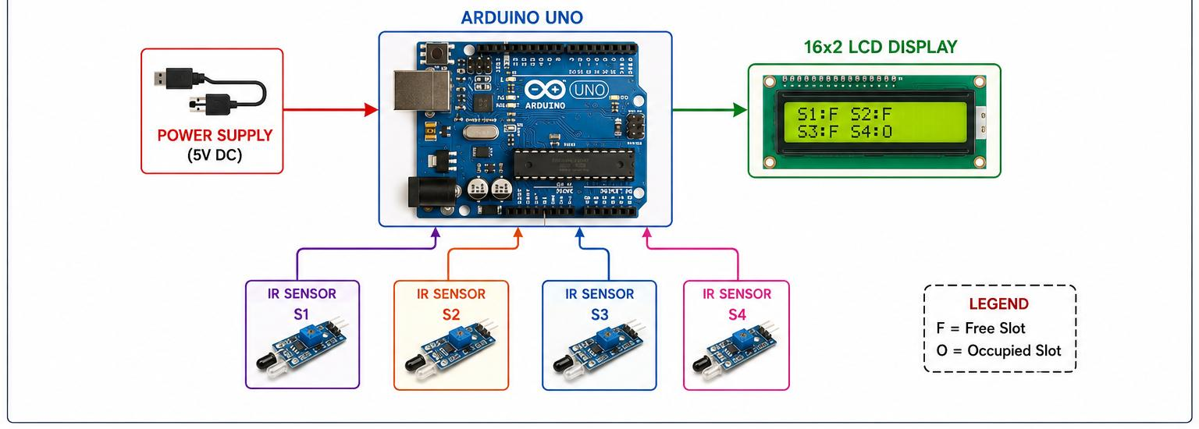

The proposed Smart Parking System is designed to monitor the availability of parking spaces automatically and display the status in real time. The system consists of four IR sensors, an Arduino UNO microcontroller, a 16×2 LCD display, and a regulated power supply. The IR sensors are placed at individual parking slots (S1, S2, S3, and S4) to detect the presence or absence of vehicles. Whenever a vehicle occupies a parking slot, the corresponding IR sensor detects the obstruction and sends a signal to the Arduino UNO. The Arduino acts as the central processing unit of the system and continuously receives data from all sensors. Based on the sensor inputs, it determines whether each parking slot is free or occupied. The processed information is then sent to the 16×2 LCD display, which shows the status of all parking slots using symbols such as F (Free) and O (Occupied). The power supply provides the necessary voltage to all hardware components, ensuring smooth and uninterrupted operation. This arrangement enables efficient parking management, reduces manual monitoring, and helps drivers quickly identify available parking spaces.

3.2. CIRCUIT DIAGRAM

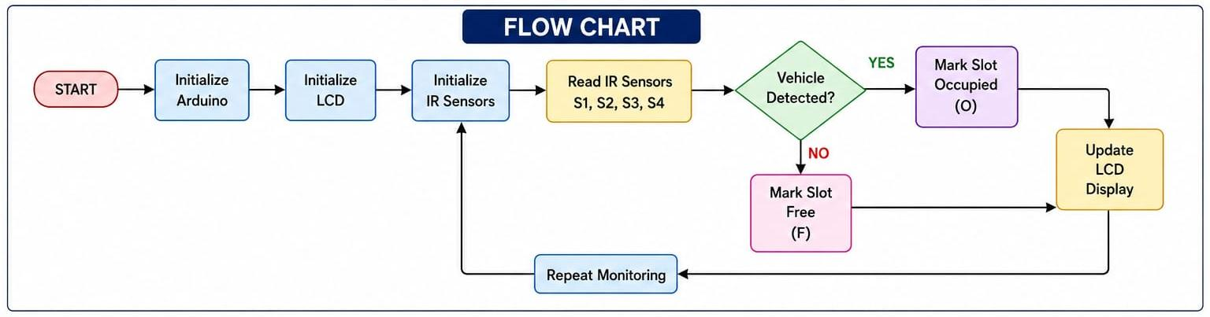

The operation of the Smart Parking System starts when power is supplied to the Arduino UNO and other connected components. Initially, the Arduino initializes the LCD display and configures all IR sensors as input devices. After successful initialization, the system enters a continuous monitoring mode. In this stage, the Arduino reads the status of each IR sensor connected to the parking slots. The controller then checks whether a vehicle is present in a particular slot. If the sensor detects a vehicle, the corresponding parking slot is marked as Occupied (O). If no vehicle is detected, the slot is marked as Free (F). After processing the status of all parking slots, the Arduino updates the information on the LCD display. The display shows the current availability of parking spaces, allowing users to identify vacant slots easily. Once the display is updated, the system does not stop; instead, it continuously repeats the monitoring process by reading sensor values again. This loop continues indefinitely, ensuring real-time parking slot status updates. The automated process minimizes human effort, improves parking efficiency, reduces traffic congestion inside parking areas, and provides a reliable solution for smart parking management.

3.3. COMPONENTS LISTS

- Microcontroller (Arduino / ESP32)

- IR Sensors / Ultrasonic Sensors

- Servo Motor

- LCD Display (16x2)

- Power Supply

- Breadboard and Connecting Wires

- LED Indicators

CHAPTER-4
COMPONENT’S USED
4.1. ARDUINO

Arduino UNO is the main controller and the most important component of the Smart Parking System. It is based on the ATmega328P microcontroller and acts as the brain of the entire project. The Arduino receives input signals from all the IR sensors placed in the parking slots and processes the data according to the programmed instructions. Based on the sensor readings, it determines whether a parking slot is free or occupied. After processing the information, the Arduino sends the corresponding output to the LCD display. It contains digital input/output pins, analog pins, a USB interface, a voltage regulator, and a microcontroller chip, making it suitable for various embedded applications. The Arduino UNO is widely used because of its simplicity, low cost, reliability, and ease of programming using the Arduino IDE. In this project, it continuously monitors all parking slots and updates the display in real time.

The Arduino UNO also plays an important role in decision-making within the system. Whenever a vehicle enters or leaves a parking slot, the sensor status changes. The Arduino immediately detects this change and updates the display accordingly. Due to its fast processing speed and low power consumption, it ensures efficient operation of the parking management system. It serves as the bridge between the sensing unit and the display unit, making the entire system work as an integrated solution. Arduino UNO is a programmable development board that forms the intelligence of the Smart Parking System. It not only collects data from the sensors but also analyzes the information and makes decisions based on the programmed algorithm. The microcontroller operates continuously and performs thousands of calculations every second to ensure that the parking status shown on the LCD is always accurate. Arduino UNO supports serial communication, making it easy to connect with computers, wireless modules, IoT devices, and other peripherals. Its open-source nature allows developers to modify and improve the system according to future requirements.

Another important feature of Arduino UNO is its memory organization. It contains Flash Memory for storing programs, SRAM for temporary data storage, and EEPROM for permanent data storage. These memory sections help the controller execute the parking management program efficiently. Due to its robustness and versatility, Arduino UNO has become one of the most popular platforms for smart city, automation, robotics, and embedded system applications.

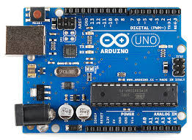

4.2. IR SENSOR

The Infrared Sensor Module is used as the sensing element in the Smart Parking System. It is responsible for detecting the presence of vehicles in parking slots. Each IR sensor consists of two main parts: an infrared transmitter and an infrared receiver. The transmitter emits infrared rays continuously, while the receiver detects the reflected rays from nearby objects. When a vehicle is parked in a slot, the emitted rays are reflected back and detected by the receiver, indicating the presence of the vehicle.

IR sensors are widely used because they provide fast response, high reliability, low cost, and easy installation. In this project, multiple IR sensors are installed, with each sensor assigned to a specific parking slot. These sensors continuously monitor the parking area and send digital signals to the Arduino controller. The controller interprets these signals and identifies whether a slot is occupied or vacant. The use of IR sensors eliminates the need for manual monitoring and increases the accuracy of parking space detection.
Another advantage of IR sensors is their low power consumption and compact size. They can operate continuously for long periods without requiring significant energy. Their simple working principle and efficient performance make them ideal for smart parking applications. By providing accurate vehicle detection, the sensors improve parking management efficiency and help drivers find available spaces quickly.

The IR sensor module is one of the most important sensing devices used in the Smart Parking System. Its main purpose is to detect the occupancy status of parking spaces automatically. The sensor works on the principle of infrared reflection. Whenever a vehicle is present in front of the sensor, the emitted infrared rays strike the vehicle surface and are reflected back to the receiver. This reflection is interpreted as the presence of a vehicle.

The IR sensor module generally contains a comparator circuit and an adjustable potentiometer. The potentiometer allows users to adjust the detection range according to the parking environment. This flexibility helps improve the accuracy of vehicle detection. The sensor module is highly reliable because it can operate continuously without physical contact with the vehicle. Since there are no moving parts, maintenance requirements are very low. The fast response speed of IR sensors ensures immediate updates whenever a vehicle enters or exits a parking slot.

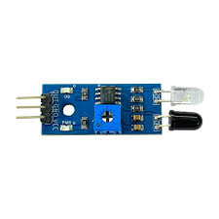

4.3 LCD DISPLAY

A 16×2 LCD (Liquid Crystal Display) is an electronic display module commonly used in
embedded systems and microcontroller projects such as Arduino, Raspberry Pi, and other
development boards. The term 16×2 means the display has 16 columns and 2 rows, allowing
it to show 32 characters at a time (16 characters per row). It is mainly used to display text,
numbers, sensor readings, system status, and messages. The LCD operates using a controller
(usually HD44780 compatible) and can work in 4-bit or 8-bit mode. It consists of 16 pins,
including power supply pins, control pins (RS, RW, EN), data pins (D0–D7), and backlight
pins (LED+ and LED−). The RS pin selects command or data mode, RW chooses read or write
operation, and EN enables data transfer. The LCD is popular because it is low-cost, easy to
interface, consumes less power, and provides clear visibility. It is widely used in digital
clocks, calculators, home automation systems, industrial control systems, and various
embedded applications for displaying information to users.

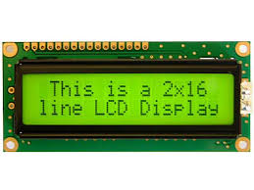

4.4. SERVO MOTOR
A servo motor is an electromechanical device used for precise control of angular position and movement.
It consists of a DC motor, gears, a control circuit, and a feedback mechanism that allows it to rotate to a specific angle based on input signals. In a Smart Parking System, the servo motor is used to automate the
opening and closing of the parking gate. When a vehicle is detected and a parking spot is available, the
Arduino microcontroller sends a control signal to the servo motor, causing it to rotate and open the gate. After the vehicle enters or exits the parking area, the servo motor returns to its original position and closes the gate
automatically. Servo motors are preferred because they provide accurate position control, consume less power, respond quickly, and are easy to interface with microcontrollers. Their reliable and efficient operation makes them suitable for automation applications such as smart parking systems, robotic arms, automatic doors, and industrial control systems. By using a servo motor, the Smart Parking System becomes more secure, efficient, and user-friendly, reducing the need for manual gate operation and improving overall parking management.

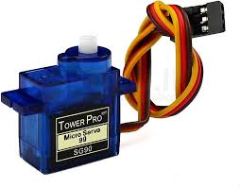

CHAPTER – 5
WORKING PRINCIPLE

The Smart Parking System is designed to automate the process of parking management by detecting
available parking spaces and providing real-time information to users. The system uses IR sensors, an Arduino Uno microcontroller, a servo motor, and an LCD display to monitor and control parking operations efficiently. The main objective of the system is to reduce the time required to find a parking space, improve parking utilization, and minimize traffic congestion within parking areas.

The working process begins when the system is powered on. The Arduino Uno initializes all connected devices, including the IR sensors, LCD display, and servo motor. IR sensors are installed in each parking slot to continuously monitor the presence or absence of vehicles. These sensors emit infrared rays and detect reflections from nearby objects. When a vehicle occupies a parking slot, the infrared beam is interrupted or reflected, and the sensor generates an output signal indicating that the slot is occupied.

The output from each IR sensor is sent to the Arduino Uno microcontroller. The Arduino continuously reads the sensor data and analyzes the status of every parking slot. Based on the received signals, the microcontroller identifies which slots are vacant and which are occupied. This information is processed in real time and updated whenever a vehicle enters or leaves a parking space.

The processed parking information is displayed on a 16×2 LCD display. The LCD screen shows the number of available parking slots and occupied slots, helping drivers quickly identify whether parking space is available. If multiple parking slots are present, the system can also display the status of individual slots. The display is continuously updated to ensure that the information shown is accurate and current.

A servo motor is used to automate the parking gate. When a vehicle approaches the entrance and at least one parking slot is available, the Arduino sends a control signal to the servo motor. The servo motor rotates to a predefined angle, opening the gate and allowing the vehicle to enter the parking area. After the vehicle passes through the gate, the servo motor automatically returns to its original position, closing the gate. This automatic gate control improves security and eliminates the need for manual operation.

If all parking spaces are occupied, the Arduino detects that no vacant slots are available. In this condition, the LCD display shows a message such as "Parking Full" or "No Slots Available." The servo motor keeps the gate closed, preventing additional vehicles from entering the parking area until a parking slot becomes available. When a vehicle leaves a parking slot, the corresponding sensor detects the change, and the Arduino immediately updates the parking status. The display changes accordingly, and the gate can once again allow vehicles to enter if space is available.

The system continuously repeats the sensing, processing, and updating operations throughout its operation. This real-time monitoring ensures accurate parking information and efficient management of available spaces. The automatic nature of the system reduces human effort, minimizes errors, saves fuel, decreases vehicle waiting time, and improves the overall parking experience.

Thus, the Smart Parking System provides an intelligent, reliable, and cost-effective solution for managing parking facilities in shopping malls, hospitals, airports, railway stations, educational institutions, office complexes, and smart city environments. By combining sensors, microcontrollers, displays, and automated gate control, the system enhances parking efficiency and supports modern transportation infrastructure.

5.1. TIMER/SCHEDULER LOGIC

The Timer/Scheduler Logic is used to manage and coordinate various operations at regular time intervals. The Arduino microcontroller acts as the scheduler and continuously executes different tasks such as reading sensor data, updating parking slot status, controlling the servo motor, and refreshing the LCD display. The timer ensures that these tasks are performed periodically and in the correct sequence without delays.
The system continuously checks the IR sensors installed in each parking slot to determine whether a vehicle is present or absent. At fixed intervals, the timer triggers the Arduino to read the sensor values and update the occupancy status of the parking slots. If a change is detected, such as a vehicle entering or leaving a slot, the scheduler immediately updates the parking information displayed on the LCD screen. Similarly, when a vehicle approaches the entrance gate, the scheduler processes the sensor input and activates the servo motor to open or close the gate based on parking availability.
The timer-based operation ensures real-time monitoring and quick response to changes in parking conditions. It prevents unnecessary delays, improves system efficiency, and allows multiple tasks to be performed simultaneously in an organized manner. By using timer and scheduler logic, the Smart Parking System provides accurate parking information, efficient gate control, and reliable operation, making the entire parking process smooth and automated.

5.2. CIRCUIT/ SOFTWARE INTEGRATION
Circuit and software integration is the process of connecting hardware components with software so that the Smart Parking System can monitor parking slots, process data, and provide real-time parking information to users. The hardware section consists of sensors, a microcontroller, communication modules, display units, and actuators, while the software section includes embedded programming, database management, and user interfaces.
In the Smart Parking System, sensors such as IR or ultrasonic sensors are installed in each parking slot to detect vehicle presence. These sensors continuously send signals to the microcontroller (Arduino, ESP32, or Nedelcu). The microcontroller processes the received sensor data and determines whether a parking spot is occupied or vacant. The software program embedded in the controller analyzes the sensor readings and updates the parking status accordingly.
The communication module, such as Wi-Fi or GSM, transfers the parking information from the microcontroller to a cloud server or local database. The software running on the server stores the data, performs processing, and updates the availability of parking spaces in real time. A mobile application or web dashboard retrieves this information and displays available slots to users, helping them find parking quickly.

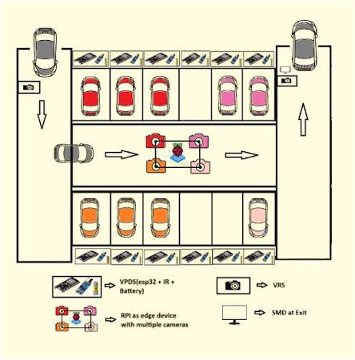

CHAPTER – 6
IMPLIMENTATION
6.1. HARDWARE SETUP
The hardware setup of a Smart Parking System consists of arranging and connecting all electronic components in a structured manner so that vehicle detection, processing, and display of parking information can be achieved efficiently. The main components include sensors, microcontroller, power supply, communication module, display unit, and gate control mechanism.
The first step is installing sensors at each parking slot. Ultrasonic sensors (like HC-SR04) or infrared (IR) sensors are fixed in such a way that they can accurately detect the presence or absence of a vehicle. These sensors are mounted at the top or side of each parking space and aligned properly to avoid false readings. Each sensor has VCC, GND, Trigger/Output, and Echo pins that are connected to the microcontroller input pins.
The microcontroller unit, such as Arduino UNO, ESP32, or NodeMCU, is placed at a central control unit. All sensor outputs are connected to this microcontroller. It acts as the main processing unit that reads sensor signals and determines whether a parking spot is occupied or free. Proper wiring is done using jumper wires or PCB connections to ensure stable communication.
A stable power supply is essential for continuous operation. A regulated 5V DC power supply or battery pack is used to power the microcontroller and sensors. Voltage regulators may be added to ensure safe voltage levels for sensitive components.
A communication module like ESP8266 Wi-Fi or GSM module is connected to the microcontroller to enable data transmission. This module sends parking status information to a cloud server or mobile application for real-time monitoring. Proper serial communication (TX/RX pins) is established between the microcontroller and the module.
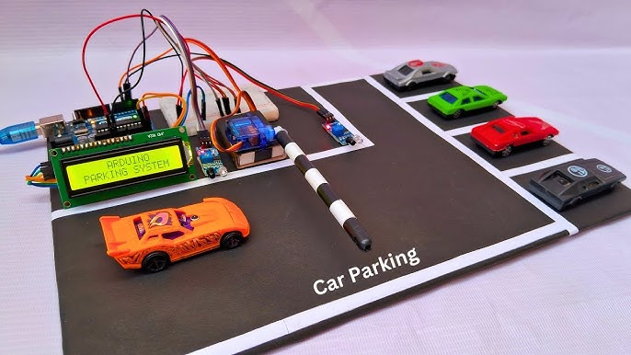

6.2. SOFTWARE CODE

The software for a Smart Parking System is developed using embedded programming languages such as C or Arduino IDE code. The main purpose of the software is to continuously read data from sensors, process it, and control the output devices like displays and gate motors. The code acts as the brain of the system and ensures proper coordination between all hardware components.

In the program, ultrasonic or infrared sensors are used to detect the presence of a vehicle in each parking slot. The microcontroller sends trigger signals to the sensors and receives echo signals back. Based on the time taken for the echo to return, the distance is calculated. If the distance is below a certain threshold value (for example, less than 10 cm), the system considers the slot as occupied. Otherwise, it is marked as vacant.

The software continuously runs in a loop so that real-time monitoring is possible. Each sensor reading is compared with predefined conditions and the status of each parking slot is updated accordingly. The program uses conditional statements like IF-ELSE to decide whether a slot is free or occupied.

The system also includes logic for gate control. When a vehicle arrives at the entry gate, the software checks the availability of parking slots. If at least one slot is available, the program sends a signal to the servo motor to open the gate. After a few seconds, the gate is automatically closed. If all slots are full, the system prevents entry and displays a “Parking Full” message.

Additionally, the software can be extended to include communication features using Wi-Fi or GSM modules. In such cases, the code sends real-time parking status to a mobile application or cloud server. This allows users to check parking availability remotely.

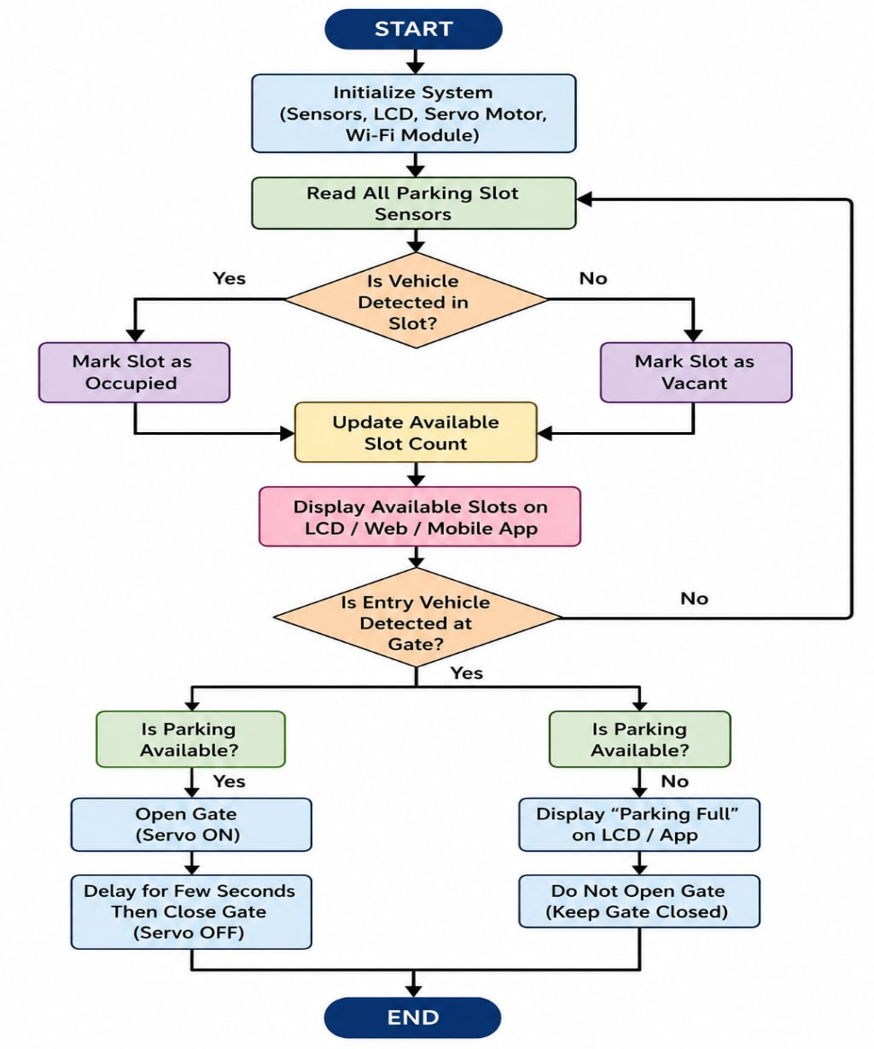

CHAPTER-7

RESULT

The Smart Parking System efficiently detects available parking slots using sensors and updates the status in real time. It automatically allows vehicle entry when space is available and displays “Parking Full” when no slots are free. The system reduces traffic congestion, saves time, and improves parking management by making the process fully automated and reliable.

It also minimizes human intervention and ensures better utilization of parking space. The system responds quickly to vehicle movement, improving overall efficiency and user convenience. This makes it suitable for smart cities, malls, and office parking areas.

Overall, the project successfully achieved its objective of smart packing system.

7.1. OUTPUT IMAGE

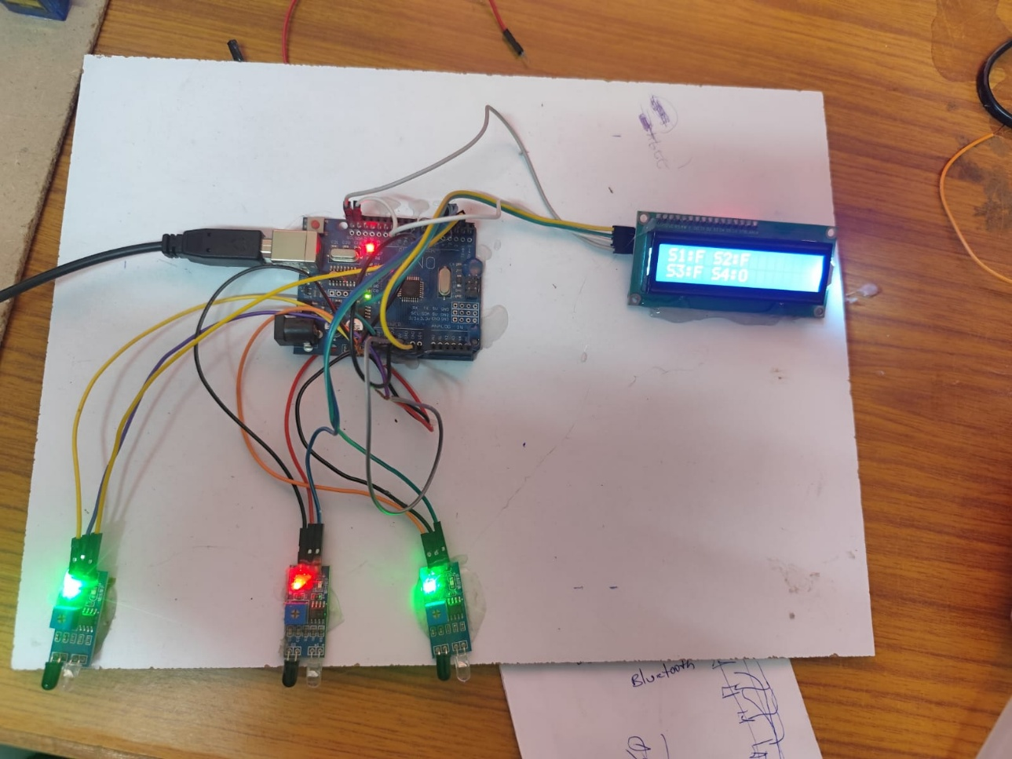

The output of the Smart Parking System is shown through an LCD display or mobile application. It continuously displays the number of available parking slots and updates in real time based on sensor detection. When a vehicle enters or leaves, the slot count automatically increases or decreases.

If parking space is available, the output shows messages like “Slot Available” or displays the specific slot number for parking. If all slots are occupied, the output clearly shows “Parking Full”, and the entry gate remains closed.

Additionally, the system may give visual indicators such as green LED for available slots and red LED for occupied slots. This real-time output helps users easily understand parking status and reduces confusion, making the system efficient and user-friendly.

7.2. TEST CASES OR DEMONSTRATIONS

Test Case 1: Vehicle Entry with Available Slot

When a vehicle arrives and at least one parking slot is free, the sensor detects the vehicle and the system updates the LCD display. The gate opens automatically using the servo motor and allows entry. The slot count decreases by one.

Test Case 2: Vehicle Entry when Parking is Full

When all parking slots are occupied, the system detects no availability. The LCD displays “Parking Full” and the entry gate remains closed. No vehicle is allowed to enter.

Test Case 3: Vehicle Exit from Parking Area

When a vehicle leaves the parking slot, the sensor detects vacancy. The system updates the slot count and increases available slots by one. The display reflects the updated status.

Test Case 4: Real-Time Slot Update

As vehicles continuously enter and exit, the system updates slot availability instantly on the display without delay.

Test Case 5: Sensor Detection Check

Each IR sensor correctly detects whether a slot is occupied or empty, ensuring accurate data for the system.

7.3. OBSERVATIONS

During the working of the Smart Parking System, it was observed that the sensors accurately detect the entry and exit of vehicles and update the parking slot status in real time. The system responds quickly, and the display correctly shows whether slots are available or if the parking area is full. The servo motor-controlled gate operates smoothly based on the availability of space, allowing vehicles to enter only when slots are free. It was also observed that the system reduces manual effort and helps in avoiding traffic congestion inside the parking area. Overall, the system performs reliably and provides an efficient and user-friendly parking management solution.

CHAPTER – 8

ADVANTAGES & LIMITATIONS

ADAVNTAGES

Real-time Monitoring

Provides live detection and updates of available parking slots.

Reduces Traffic Congestion

Helps in smooth vehicle flow inside parking areas.

Time Saving

Guides drivers quickly to empty parking spaces.

Automation

Reduces the need for manual parking management.

Better Space Utilization

Ensures all parking slots are properly used.

Smart City Support:

Improves overall traffic and infrastructure management.

LIMITATIONS

Sensor Dependency:

System accuracy depends on proper functioning of sensors.

Maintenance Required:

Regular checking and servicing of components is needed.

High Initial Cost:

Installation of sensors, controllers, and setup is expensive.

Weather Sensitivity:

Performance may be affected in extreme environmental conditions.

Power Dependency:

Requires continuous power supply for operation.

Complex Setup:

Large parking areas need complex design and calibration.

8.1. BENEFITS

Reduces traffic congestion by guiding vehicles to available slots quickly.

Saves time for drivers by eliminating the need to search for parking.

Improves space utilization by efficiently managing all parking slots.

Provides real-time updates of parking availability through sensors and display.

Reduces manual effort by automating parking management.

Enhances user convenience with clear slot indication and guidance.

Supports smart infrastructure development in malls, cities, and offices.

8.2. DRAWBACKS OR AREAS FOR IMPROVEMENT

High installation cost due to sensors, controllers, and wiring setup.

Sensor reliability issues can lead to wrong slot detection.

Regular maintenance required to ensure proper system performance.

Limited performance in harsh weather conditions like heavy rain or dust.

Power dependency may cause system failure during power cuts.

Scalability challenges when expanding to large parking areas.

Can be improved by IoT integration for better remote monitoring and mobile app access.

CHAPTER – 9

FUTURE SCOPE

The Smart Parking System has significant potential for future development and enhancement. As the number of vehicles continues to increase, the demand for intelligent and automated parking solutions is also growing. Future versions of the system can be integrated with advanced technologies to improve efficiency, user convenience, and overall parking management.
One major improvement is the integration of Internet of Things (IoT) technology, which would allow parking information to be monitored and controlled remotely through the internet. Users could check parking slot availability in real time using a mobile application before reaching their destination. This would help reduce traffic congestion and save valuable time.
The system can also be enhanced with a mobile-based reservation feature, allowing drivers to book parking spaces in advance. This would be especially useful in crowded locations such as shopping malls, airports, railway stations, hospitals, and commercial complexes. Online payment gateways can also be integrated to enable cashless parking transactions, making the process faster and more convenient.

9.1. IDEAS FOR UPGRADING

The Smart Parking System can be upgraded by integrating advanced technologies that improve its efficiency, accuracy, and user convenience. One of the most important enhancements is the addition of IoT technology, which enables real-time monitoring of parking spaces through the internet. This allows users to check parking availability remotely using a smartphone or computer before reaching the parking area.
A dedicated mobile application can be developed to display vacant parking slots, provide navigation assistance, and allow users to reserve parking spaces in advance. Online payment facilities can also be integrated to support cashless transactions, reducing waiting time at entry and exit points. The use of RFID technology and automatic number plate recognition can further automate vehicle identification and access control.

CHAPTER – 10

CONCLUSION

The Smart Parking System is a modern and intelligent solution designed to overcome the challenges of traditional parking management. In this project, sensors are used to detect the availability of parking slots, while the microcontroller processes the sensor data and controls the operation of the servo motor gate. The system continuously monitors parking spaces and provides real-time information about vacant and occupied slots, making the parking process faster and more efficient.

The implementation of this system helps reduce traffic congestion caused by vehicles searching for parking spaces. It saves time, fuel, and human effort while improving the overall parking experience for drivers. The automated operation minimizes manual intervention and increases the accuracy and reliability of parking management. Additionally, the system enhances security by maintaining proper control over vehicle entry and exit.

The project successfully demonstrates the practical application of embedded systems, sensors, and automation technologies in solving real-world problems. The results obtained show that the Smart Parking System can effectively manage parking spaces and improve utilization of available parking areas. With future enhancements such as IoT connectivity, mobile application support, cloud data storage, and online reservation facilities, the system can be expanded into a fully smart parking solution suitable for shopping malls, hospitals, airports, educational institutions, and smart city infrastructure.

In conclusion, the Smart Parking System is a cost-effective, user-friendly, and scalable solution that contributes to better traffic management, efficient use of parking resources, and improved convenience for vehicle owners. It represents an important step toward the development of intelligent transportation and smart city technologies.
CHAPTER – 11

REFERENCES

The Smart Parking System is based on the concept of automation and real-time monitoring of parking spaces using embedded systems. It uses sensors such as IR or ultrasonic sensors to detect whether a parking spot
is occupied or free. These sensors send signals to a microcontroller, which processes the data and updates the parking status accordingly. The system continuously monitors all slots and provides real-time information to users through a display unit such as an LCD.

CHAPTER – 12
APPENDIX
The appendix contains additional information and supporting materials used during the development and
implementation of the smart parking System project. It provides technical details and
supplementary content that supports the overall project documentation.

HARDWARE COMPONENTS
- Microcontroller (Arduino / ESP32)

- IR Sensors / Ultrasonic Sensors

- Servo Motor

- LCD Display (16x2)

- Power Supply

- Breadboard and Connecting Wires

- LED Indicators

SOFTWARE USED

Arduino IDE
Embedded C

CIRCUIT & CONNECTIONS
The project includes sensor interfacing with Arduino UNO, LCD display connections, and servo motor control
for smart parking system. Proper wiring and circuit design were implemented for successful operation.

OUTPUT RESULTS:

- The system successfully identified the occupied and free slots and LCD displays the detected output.

PROJECT APPLICATIONS

- Smart city applications
- Shopping malls
- Educational Institutes
- Cities

SUPPORTING DOCUMENTS

- Circuit diagram
- Program code
- Component data sheets
- Project photographs and demonstration results

12.1. FULL CODE

#include <Servo.h> #include <Wire.h>
#include <LiquidCrystal_I2C.h> LiquidCrystal_I2C lcd (0x27, 20,4);
Servo myservo; #define ir_enter 2
#define ir_back 4

#define ir_car1 5
#define ir_car2 6
#define ir_car3 7
#define ir_car4 8

int S1 = 0, S2 = 0, S3 = 0, S4 = 0;
int flag1 = 0, flag2 = 0; int slot = 4;

void setup () {Serial.begin(9600);

pinMode (ir_car1, INPUT); pinMode (ir_car2, INPUT); pinMode(ir_car3, INPUT); pinMode (ir_car4, INPUT);

pinMode (ir_enter, INPUT); pinMode (ir_back, INPUT);

myservo.attach(3); myservo.write(90);

lcd.init(); lcd.backlight();

lcd.setCursor (0, 1); lcd.print
(" Car Parking "); lcd.setCursor (0, 2); lcd.print(" System "); delay (5000);
lcd.clear();

Read_Sensor();

int total = S1 + S2 + S3 + S4; slot = slot - total;
}
void loop () {Read Sensor(); lcd.setCursor (0, 0);
lcd.print (" Available Slot: "); lcd.print(slot);
lcd.print (" ");

lcd.setCursor (0, 1); if (S1 == 1) {
lcd.print ("S1: Full ");
}
else {
lcd.print ("S1: Empty");
}

lcd.setCursor (11, 1); if (S2 == 1) {
lcd.print ("S2: Full ");
}
else {
lcd.print ("S2: Empty");
}
lcd.setCursor (0, 2); if (S3 == 1) {
lcd.print ("S3: Full ");
}
else {
lcd.print ("S3: Empty");
}

lcd.setCursor (11, 2); if (S4 == 1) {
lcd.print ("S4: Full ");
}
else {
lcd.print ("S4: Empty");
}

if (digitalRead (ir_enter) == 0 && flag1 == 0) {if (slot > 0) {
flag1 = 1;
if (flag2 == 0) {myservo.write(180); slot = slot - 1;
}
} else {
lcd.setCursor (0, 0);
lcd.print (" Sorry Parking Full "); delay (1500);
}
}

if (digitalRead (ir_back) == 0 && flag2 == 0) {flag2 = 1;
if (flag1 == 0) {myservo.write(180); slot = slot + 1;
}
}

if (flag1 == 1 && flag2 == 1) {delay (1000); myservo.write(90);
flag1 = 0, flag2 = 0;
}

delay (1);
}
void Read_Sensor () {
S1 = 0, S2 = 0, S3 = 0, S4 = 0;

if (digitalRead(ir_car1) == 0) {S1 = 1;
}
if (digitalRead(ir_car2) == 0) {S2 = 1;
}
if (digitalRead(ir_car3) == 0) {S3 = 1;
}
if (digitalRead(ir_car4) == 0) {S4 = 1;
}

12.2. DATA SHEETS
Project Title
Smart parking system

PROJECT OBJECTIVE
To automatically detect the occupied or empty slots for smart parking mechanism using Arduino

MICROCONTROLLER
- Arduino UNO
- Operating Voltage: 5V
- Input Voltage: 7–12V
- Digital I/O Pins: 14
- Analog Input Pins: 6
- Clock Speed: 16 MHz
- Function: Processes sensor data and controls output
- IR SENSOR
- Operating Voltage: 3.3V–5V
- Output Type: Analog
- Connected Pin: A0
- Function: Detects free slots and occupied slots.
- SERVO MOTOR
- Operating Voltage: 4.8V–6V
- Connected Pin: D9
- Rotation Range: 0°–180°

LCD DISPLAY
- Operating voltages 5V
- I2C Address 0x27
- Function: Displays Systems Output

SYSTEM OUTUT
- LCD displays sensor activates
- Servo motor activates automatically
- Slots are automatically predicted
APPLICATIONS
- Shopping malls
- Airports
- Educational Institutions
- Office

